
Physics Lab

Department of MPS

Course Name : Engineering Physics - 1

Course Code : PHY 109 LAB

Section No :

Group No :

Experiment No :

Name of the Experiment :

Date of Allocation :

Date of Submission :

Submitted To :

Student’s ID :

Student’s Name :


Physics Lab

PHY-109 LAB

Experiment No: 02
Name of the Experiment:
To determine the refractive index of the material of a prism.

Theory :
When light of certain color undergoes by refraction through a prism, then the refractive index of the material of the prism for light of certain color (wave length) is given by the relation
………………………………………………….(1)
Where, A = prism angle
δ_{m} = minimum deviation.
the expression for μ can be deduced in the following manner.

If a ray PQ (Fig - 1) is incident on the first face of a prism and after passing through the principal plane of the prism, finally emerge out through the other face in the direction RS.  Let i and r be the respective angles of incidence and refraction at the first face of the prism and r ' and e the corresponding quantities for the second face.  Now the deviation(δ) of the ray is  …(2)  In quadrilateral AQFR,  ( MF and NF are normal)  …………..(3)  Again, in triangle QFR,  ………...…..(4)  ……………..(5)  ………..…..(6) | 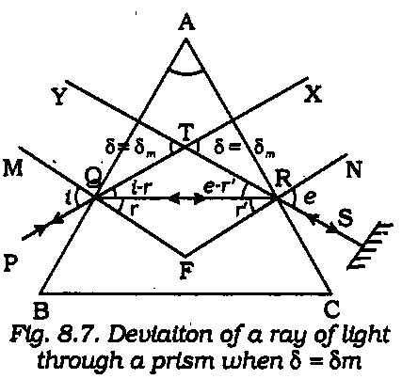  Figure – 1: Refraction of light through prism.
But in the position of minimum deviation (δ_{m}), the ray passes symmetrically through the prism
so that i = e and r = r ' .Therefore we can write from (5) and (6),
Now refractive index of the material of the prism is ……………..( 7 )

Apparatus: (1)Spectrometer, (2)Sodium lamp, (3)Prism, (4)Spirit level, (5)Reading lens, etc

Procedure:

- Make all the necessary adjustments of the spectrometer including focusing for parallel rays by Schuster's method in the usual manner. Determine the vernier constants of both the vernier. Now place the prism on the prism table in such a way that the vertex of the prism coincides with the center of the prism table.  - Now determine the angle of the prism by following the figure-2  - To determine the angle of minimum deviation, place the prism on the prism table that the center of the prism is on the center of the table and its refracting faces, say AB in Figure-3 is directed toward the collimator.  - Looking through other face (AC) of the prism, determine the position of the refracted image of the slit with an unaided eye. Turn the prism table so that the deviation gradually decreases. At the same time follow the image. Gradually the image will approach as near to the direct path of the rays from the collimator as possible. On further turning the table in the same direction, the image will found to move back. This point of turning back is the position of the minimum deviation. | 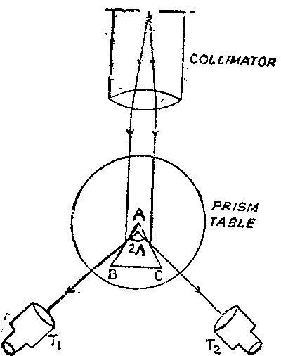  Figure : 2 : Determination of prism angle
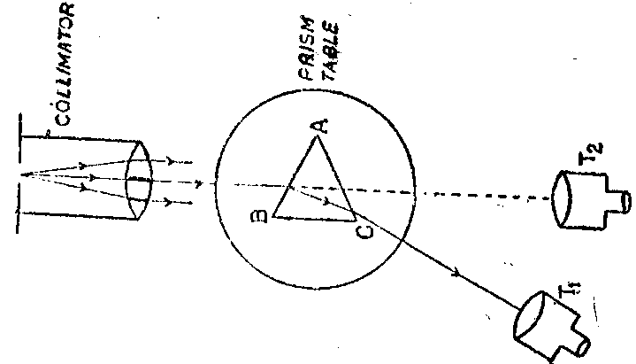
Figure: 3 : Determination of minimum deviation

- The telescope is now brought approximately to the position of minimum deviation of the image. If the image is not already in the field of view, a slight adjustment this way or that way will bring it in the field of view. Next by turning the prism table, set the image exactly at its position of minimum deviation. Rotate the telescope at the same time so that the image always remains near the intersection of the cross-wires. Once the position of minimum deviation of the image is determined, the intersection of the cross-wires is focused on the image. The fine adjustments of the telescope at this stage should always be done by the tangent screw. Now read the two verniers attached to the main scale.

- Repeat the adjustment for minimum deviation at least three times. Note the readings and mean separately for both the vernier readings.

- Remove the prism and receive the direct light by the telescope. In this time the image should be focused on the intersection of the cross-wires. Note the readings on the both verniers. Repeat the operation three times and take the mean separately for both the vernier.

- Determine separately the difference between the mean readings for the minimum deviated rays and direct rays for each vernier. This difference is the angle of minimum deviation (δ_{m}). Take the mean of the two vernier readings.

- From known values of A and δ_{m}, calculate μ by using equation ( 7 ).

DATA SHEET:

- Table for angle of the prism(A):
Vernier Scale No. | No . of Observation | Reading for image at the  Face AB of the Prism |  |  | Reading for image at the  Face AC of the Prism |  |  | Θ=T₂ ~ T₁ | Mean  Θ  degree | Angle of  the prism  A= Θ/2  degree
 |  | Main  Scale  Reading  (M) | Vernier Scale Reading  V = Div.V.C. | Total  Reading  T₁=M+V  degree | Main  Scale  Reading  (M) | Vernier  Scale  Reading  V = Div.V.C. | Total  Reading  T₂=M+V  degree
I
II

- Table for the minimum deviation (δ_{m}):

Vernier Scale No. | No. of Observation | Reading for Direct Position |  |  | Reading for Minimum Deviated| position |  |  | δ_{m} =T₂ ~ T₁  degree | Mean  δ_{m}  degree
 |  | Main  Scale  Reading  (M) | Vernier Scale Reading  V = Div.V.C. | Total  Reading  T₁=M+V  degree | Main  Scale  Reading  (M) | Vernier Scale  Reading  V = Div.V.C. | Total  Reading  T₂=M+V  degree
I
II

Calculation:

Experimental value of refractive index (measured by experiment) = ………………

Standard value of Refractive index = 1.52 (known crown glass)

Percentage difference = ……………………..

Results:

Refractive index of material of the prism = ……………………….

Discussions:

- The source must be in front of the collimator slit so that image appears bright.

- The vertical cross-wire or the centre of the cross-wires should be made coincident with the same edge of the slit image. Care should be taken so that there is no parallax between the cross-wires and the slit image.

- For the final setting, the telescope must be rotated carefully with the tangent screw always in the same direction so as to avoid back-lash error.

- While measuring the angle of the prism, the vertex of the prism should be placed at the center of the table.

- Always use both the verniers to avoid eccentric error.

- While handling a prism, never tough the refracting faces. Always hold it between the thumb at the bottom and the other fingers at the top. The faces of the prism should be cleaned with a clean piece of fine linen, if necessary.

(vii) The width of the slit image should be as narrow as possible.

(viii) In taking reading care should be taken to ascertain whether the zero of the main circular scale has been crossed in going from one position to other.

Sample oral Questions and Answers

- What are the different parts of a spectrometer?

Ans : Different parts of a spectrometer are collimator , prism table , telescope, circular scale, etc.
Collimator : It gives rise to a parallel beam of light which falls on a prism placed on the prism table.
Prism table : It is a small circular table on which prism is placed.
Telescope : A virtual image at infinity is produced by the telescope.
Circular scale : Rotation of telescope can easily be read off independently from the circular scale.

- Why the spectrometer should be leveled before its use?

Ans : Otherwise the position of the image will change with the position of the telescope i.e. , will be different for different positions of the telescope.

- What do you mean by “eccentric error”? How is this eliminated?

Ans : This error arises from the fact that the axis of the telescope and prism table may not coincide with the axis of the instrument. By using two vernier scales this error is eliminated.

- What do you mean by monochromatic light? Is sodium light strictly monochromatic?

Ans : Light consisting of only one particular wavelength is known as monochromatic light. No, sodium light is not monochromatic. It consists of light of two wavelengths of values 5890 A.U. and 5896 A.U.

- Why do you take sodium light not white light?

Ans : Because , it gives a single image of the slit and a single value of minimum deviation while white light gives a spectrum and value of minimum is different for different colors.

- How does the deviation of a ray vary with its angle of incidence?

Ans : For a particular angle of incidence , the deviation becomes minimum . But the deviation becomes greater if the angle of incidence is increased or decreased than that value.

- What is the condition for obtaining minimum deviation?

Ans : The angle of incidence must be equal to the angle of emergence.

- How does the deviation change with the color of light?

Ans : Deviation increases with shorter wavelengths e.g., it is greater for violet than for red light.

- What are the factors on which the refractive index µ depends?

Ans : Refractive index depends , among others, on (a) material of the prism (b) the color of the light.

Pre-Lab Exercise:

- What is refractive index? Which color of light has greatest refractive index? And why?

..............................................................................................................................................................................

..............................................................................................................................................................................

..............................................................................................................................................................................

- The refractive index of glass with respect to air is 1.5. The speed of light in air is approximately 3×10⁸ m/s. What is the speed of light in glass?

..............................................................................................................................................................................

..............................................................................................................................................................................

..............................................................................................................................................................................

- When light passes from air to glass then incident angle is 45⁰ and refracted angle is 28⁰ . Find the refractive index of glass with respect to air.

..............................................................................................................................................................................

..............................................................................................................................................................................

..............................................................................................................................................................................

- Refractive indexes of water and glass are 1.33 and 1.5 correspondingly. If light passes from glass to water then what direction will light bend (towards normal or away normal)?

..............................................................................................................................................................................

..............................................................................................................................................................................

..............................................................................................................................................................................

- What are the minimum deviation and prism angle?

..............................................................................................................................................................................

..............................................................................................................................................................................

..............................................................................................................................................................................

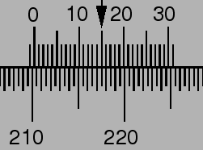
$$Vernier Constant=\frac{Value of One Division in Main Scale}{Number of Divisions in Vernier Scsle}$$
$$=\frac{{0.5}^{°}}{30}=\frac{1^{°}}{60}$$
$$Total Reading=Main Scale Reading+Vernier Scale Rading$$
=${ 210}^{°} + 15×\frac{1^{°}}{60}$
=${ 210}^{°} + {.25}^{°}$
=${210.25}^{°}$

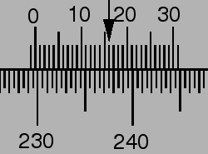
$$Total Reading=Main Scale Reading+Vernier Scale Rading$$
= $………. + ………×………$
=$……… + ………$
=$………$

